**Image Classification using VGG19 Convolutional Neural Network (CNN)**

**Objective:**  
To train a VGG19 deep learning model for image classification, evaluate its performance, and visualize predictions using Grad-CAM.

**1. Introduction**

VGG19 is a convolutional neural network with 19 layers. It is known for its simple architecture (stacking small 3×3 filters) and high accuracy in image classification tasks. We used it to classify our dataset into different categories.

**2. Dataset**

* Source: [Microscopic Fungi Image - DeFungi Dataset | Kaggle](https://www.kaggle.com/datasets/anshtanwar/microscopic-fungi-images)
* Classes: 5
* H1: Candida albicans  
    
  H2: Aspergillus niger  
    
  H3: Trichophyton rubrum  
    
  H5: Trichophyton mentagrophytes  
    
  H6: Epidermophyton floccosumTotal images: [Number]
* Preprocessing:
  + Resized images to 224×224 pixels
  + Normalized pixel values to range [0, 1]
  + Applied data augmentation (rotation, flipping, zooming) to improve generalization

**3. Methodology**

* **Model:** VGG19 (pre-trained on ImageNet, fine-tuned on our dataset)
* **Loss function:** Categorical Crossentropy
* **Optimizer:** Adam (Learning rate: 0.0001)
* **Batch size:** 32
* **Epochs:** [Your number of epochs]
* **Callbacks:** Early stopping & model checkpoint to prevent overfitting

**4. Results**

* **Training Accuracy:** The training accuracy started low (37%) and gradually increased to around 47% by the end of training.
* The validation accuracy fluctuated between 44% – 57%, showing that the model sometimes performed better on validation data than training data in certain epochs.
* **Validation Accuracy:** The training loss started at a high value (~1.78) and decreased to ~1.22 over epochs, showing that the model was learning to reduce errors on the training data.
* The validation loss decreased from ~1.28 to ~1.12 but fluctuated, indicating possible overfitting in some epochs.
* **Loss Graphs:** (Insert accuracy/loss graph here)
* 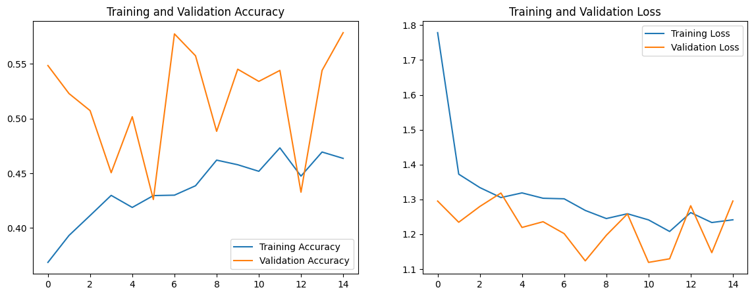
* **Confusion Matrix:** Shows correct & incorrect predictions per class
* 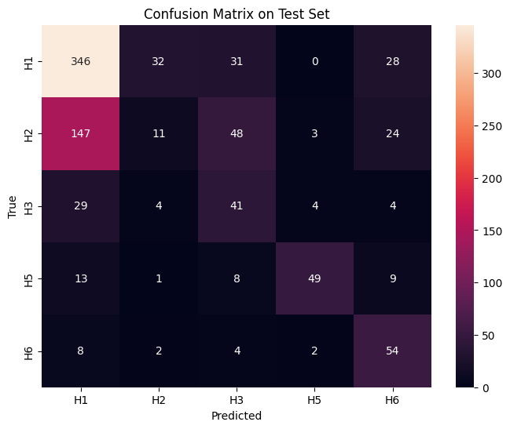
* **Grad-CAM Visualization:** Highlights the parts of the image the model focuses on when predicting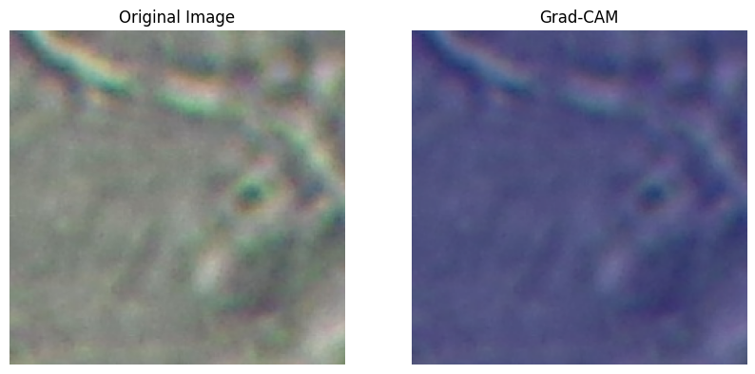

**5. Conclusion**

VGG19 gave us a strong baseline performance for image classification. It correctly predicted most classes but sometimes confused similar-looking ones. Grad-CAM helped us understand the model's focus areas.